Years 5 and 6 WEEK 4 - Animals
Weekly Maths Tasks (Aim to do 1 per day) | Weekly Reading Tasks (Aim to do 1 per day)
- Get your child to play on ​Times Table  Rockstars​. If your child works on ​Numbots ​in school they can access this with the same login.  - Ask your child to show everything they know about decimal numbers and/or percentages on a piece of paper. This could be pictures, diagrams,  explanations, methods etc. Get them to be as creative as they want to be.  - Encourage your children to compar​e decimal numbers on this game.​  - Arithmetic practise on Maths Frame.​  - Get your child to work on their reasonin​g and problem solving by practising past​ SATs questions that are broken down into topic areas and have videos linked to them that can be watched if needed.  - Try to complete the attached arithmetic test (Year 5 should be able to do most of it. Could you research how to solve the trickier Year 6 questions?). | - Remind your child to continue to read a chapter from their home reading book or a book that they have borrowed from the library.  - Explore the Highwayman Poe​m.​ Can they learn it by heart? Can you write a paragraph summarising it what this extract is about?  - Download ‘A Pinch of Magic’ from authorfy (at the bottom). Your child can then complete​ the questions on page 4.  - Complete the attached comprehension about The Highwayman
Weekly Spelling Tasks (Aim to do 1 per day) | Weekly Writing Tasks (Aim to do 1 per day)
- Encourage your child to practise the  Year 5/ 6 spelling badges  - Ask your child to choose one word at a time and use it correctly in a sentence.  - Practise spellings on Spelling Shed  - Practise this week’s spellings  Spelling FocusHomophones: cereal/serial, father/farther, guessed/guest, morning/ mourning, who’s/whose  Use the homophone cards.  Put pupils in groups of four to five to play Pairs.  Place the cards face down on the table and ask children to turn two cards over to try to find a pair.  They can only keep the pair if they can explain to the group what each word means or give an example using the correct context.  The group can use dictionaries to check.  One person in each group records the sentences used to show meaning.  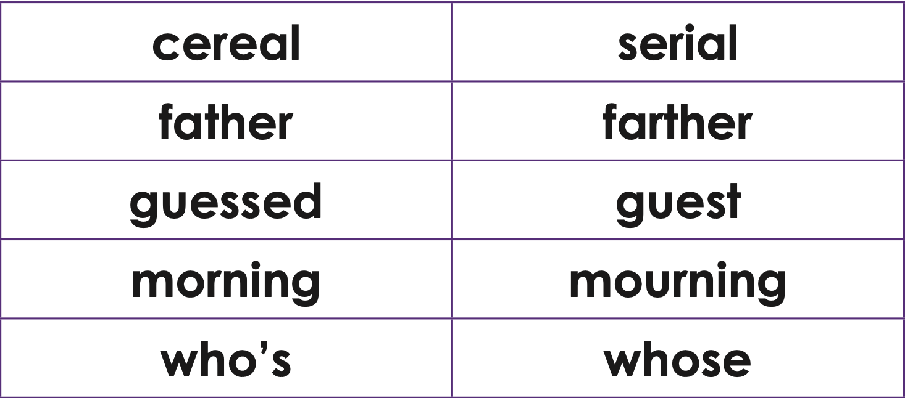 | - Write a diary entry/newspaper report summarising the events from the day/week.  - Your child can write a formal letter to West Midlands Safari Park persuading them to close the park. They must justify their opinions with factual information.  - Choose an animal of their choice and think about how it moves, what sounds it makes and the environment that it lives in. Your child can then write a poem based around these ideas. They can repeat this activity for different animals.  - Your child now has an in-depth story plan. They can begin to write their story considering the devices needed for their genre. How will the dialogue convey their character and advance the action?  - Animal’s hearts should be cut up for science experiments. ​Do you agree/disagree? Ask your child to write a discussion about this statement.

Learning Project - to be done throughout the week
The project this week aims to provide opportunities for your child to learn more about key animals they are interested in. Learning may focus on exploring the physical aspects of an animal, their habitat, categorising animals etc.

- Animals and their Environment- Your child can describe how animals such as​
Emperor Penguins, chimpanzees and orcas have adapted to suit their environment. They can do this by creating a powerpoint or other presentation after carrying out some research. After this, ask them to design a new wondrous animal that has evolved to suit its environment considering the environmental changes it has had to face over recent years. This could be completely made up.

- Life Cycles - Ask your child to research a mammal, an insect, an amphibian, a​ reptile and a bird. They can then choose one and draw the life cycle of an animal and label the diagram accordingly. How does the life cycle of the chosen animal differ to a human life cycle?

- Animal Prints-​ Using a variety of media (this could be materials from around the house such as cloth, newspapers or magazines, felt, etc.), ask your child to create animal prints for a mammal, an insect, an amphibian, a reptile and a bird of their choice. After, they can create a collage of the animal prints they have made. They could always use a pencil or pen to sketch the animal prints!

- The Life of Darwin- Who was Charles Darwin? Ask your child to research the​ scientist’s theory on evolution. Where are the Galapagos Islands? What species did and do still live there? What makes these animals unique and extraordinary? Write a biography about the life of Charles Darwin.
Additional learning resources parents may wish to engage with
Twinkl ​ - to access these resources click on the link and sign up using your own email​ address and creating your own password. Use the offer code UKTWINKLHELPS.

